Create SRS for Hospital Management system

Create SRS for Student Information system.

Create SRS for Library Information system.

Identify Functional and Non-Functional requirements of any BANK

Design DFD for Ola application. 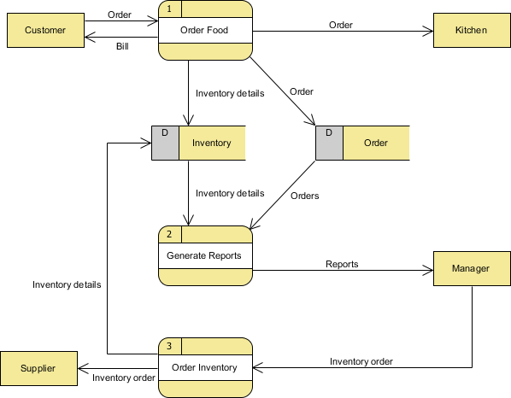

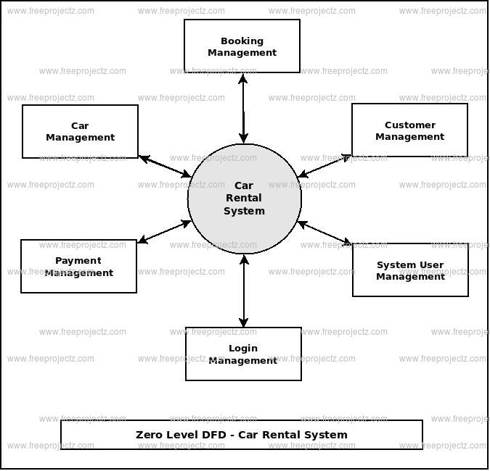

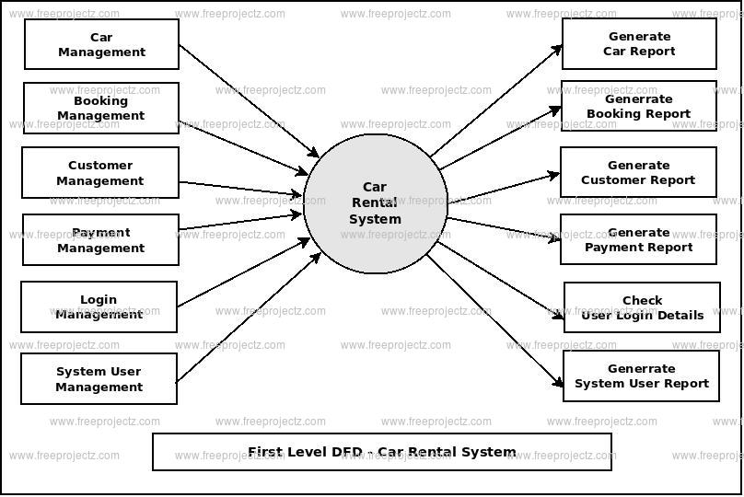

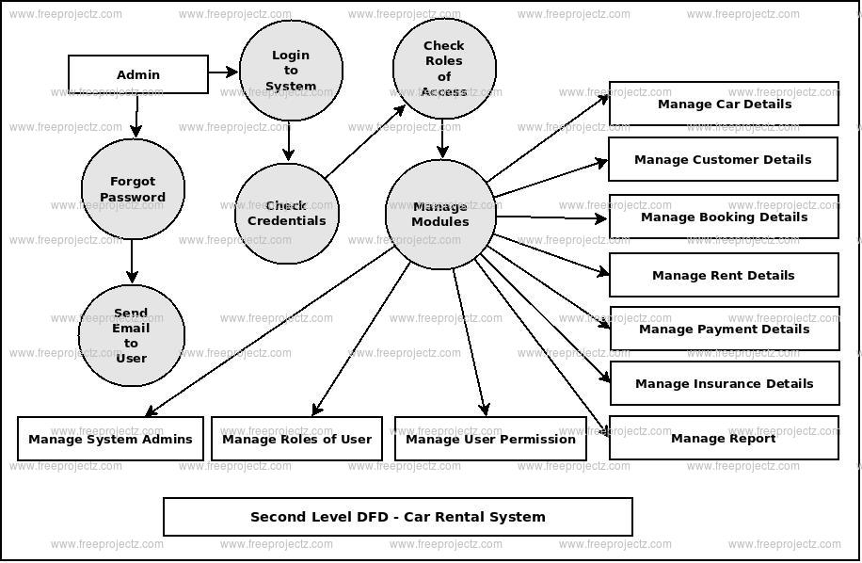

Design DFD for requirements of Campus Website.

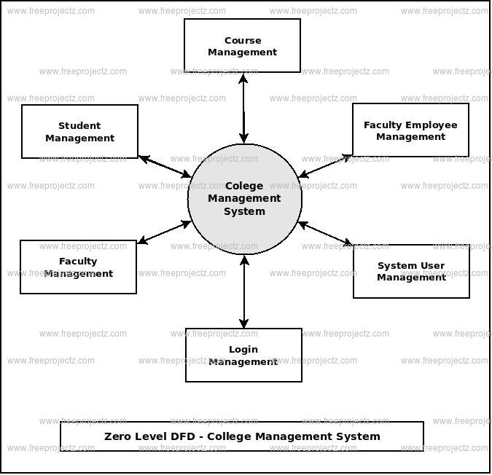

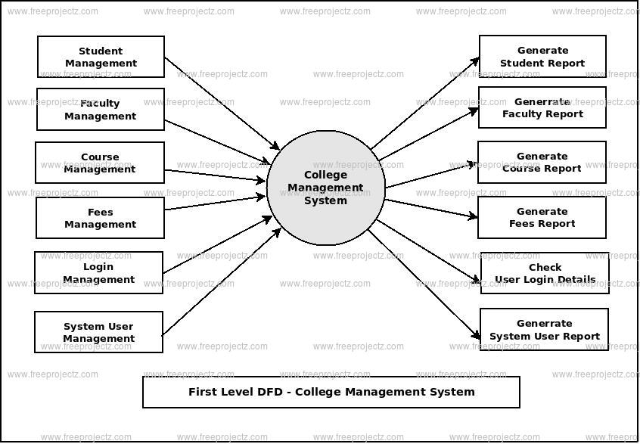

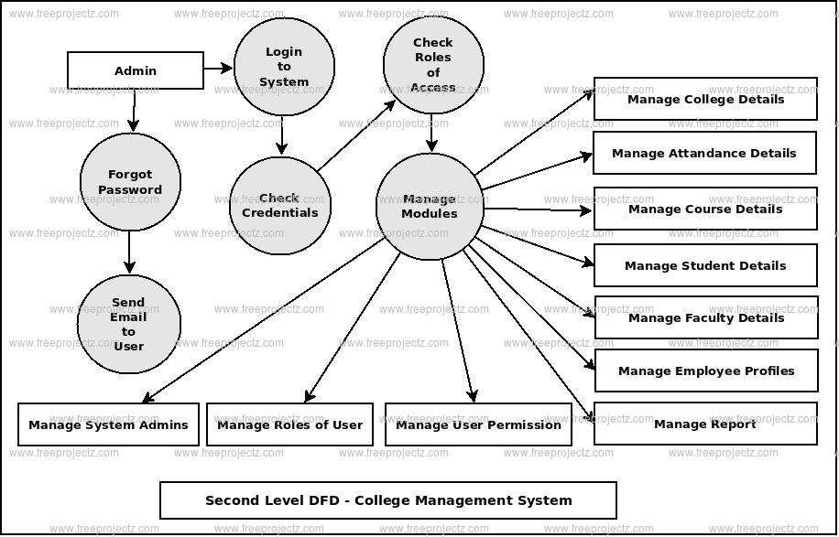

Design DFD of Carpooling application.

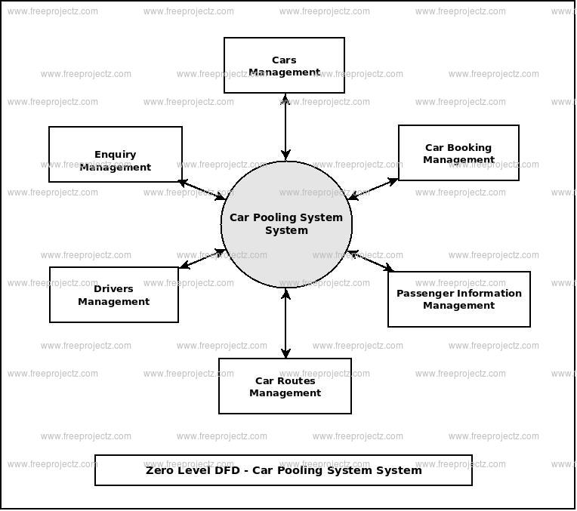

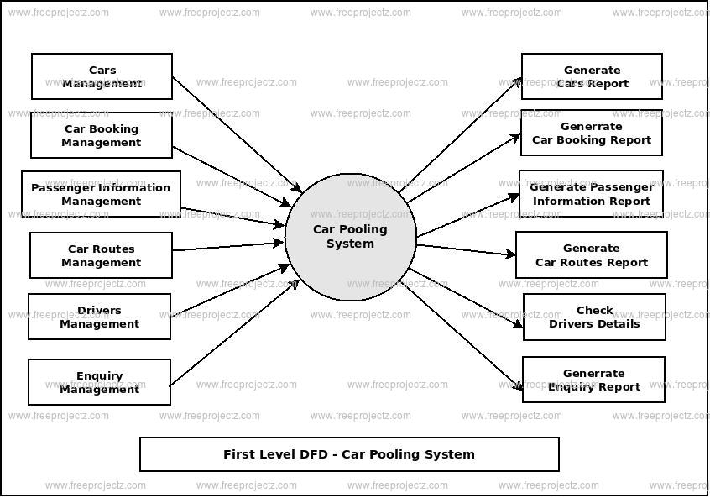

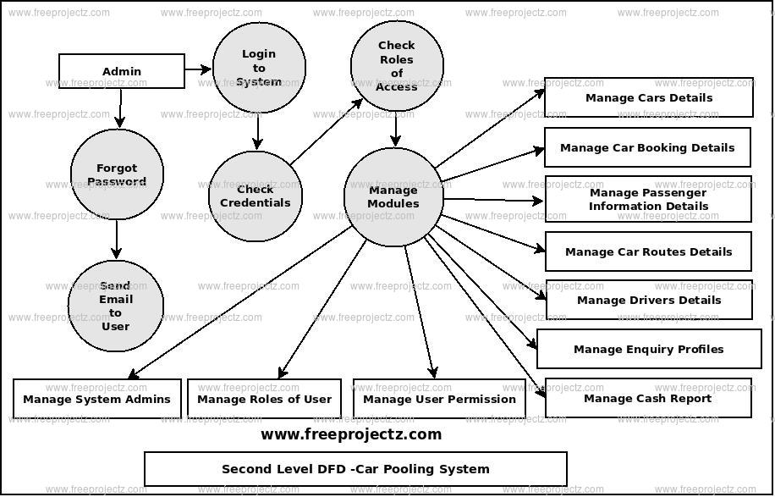

Show the Functional Decomposition of Hospital Management system

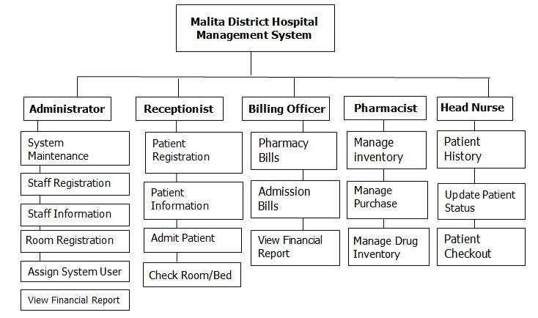

Design FDD for Online Banking system

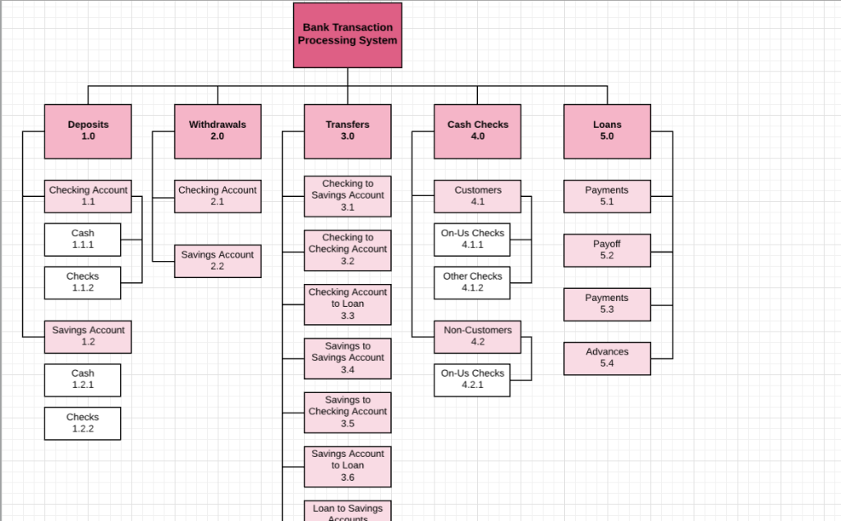

Design Use case diagram of Railway Reservation System. 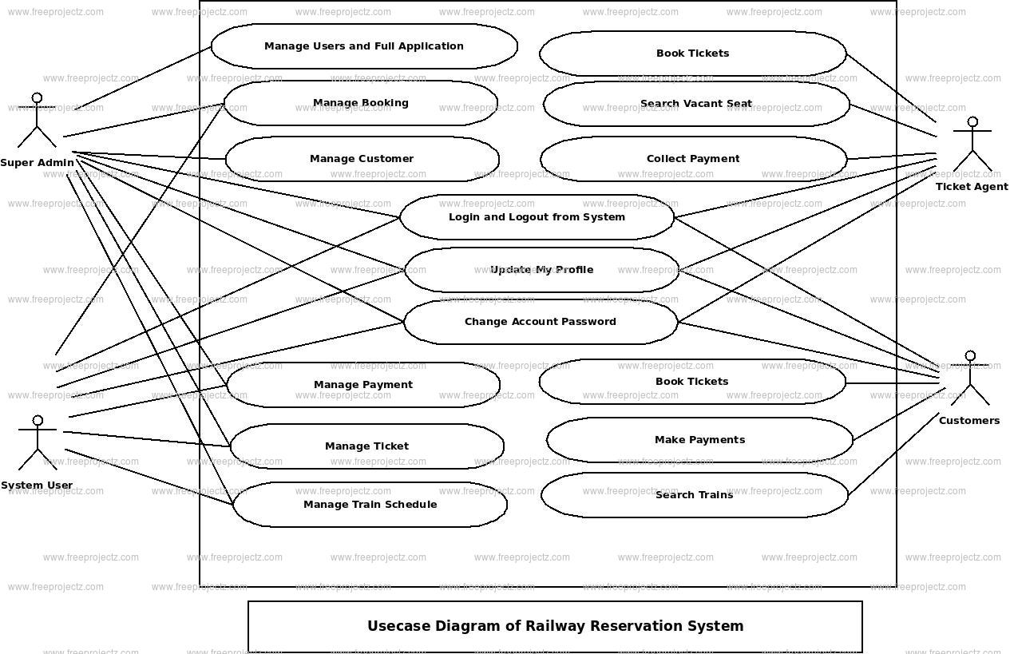

Design Use case diagram of hotel management system. 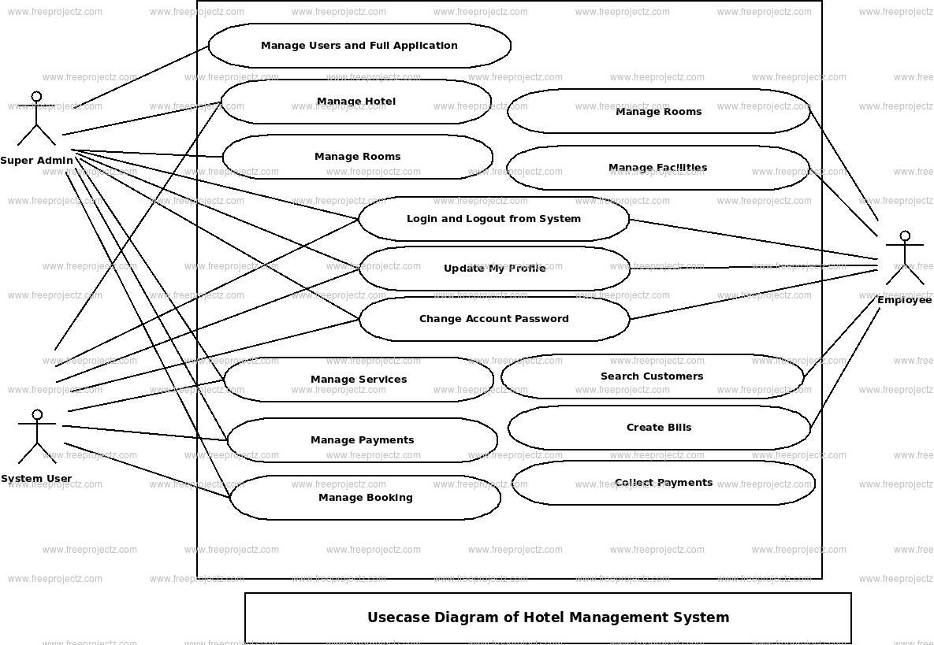

Design Use case diagram of School management system.

Design Use case diagram for Online movie ticket booking. 

Design Use case for ATM machine.

Draw the sequence diagram for ATM

Design Collaboration diagram of Car-Pooling application.

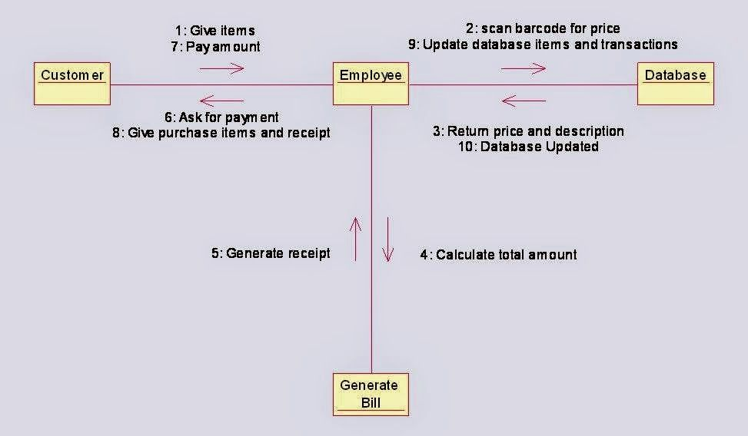

Design a Collaboration diagram for online shopping application

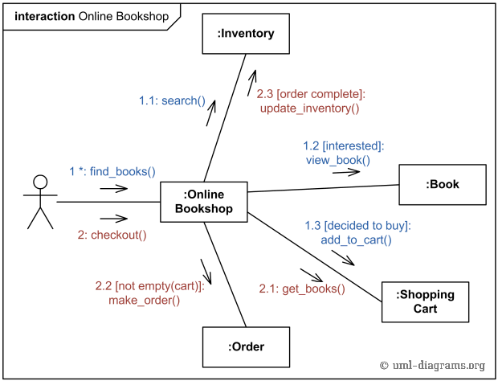

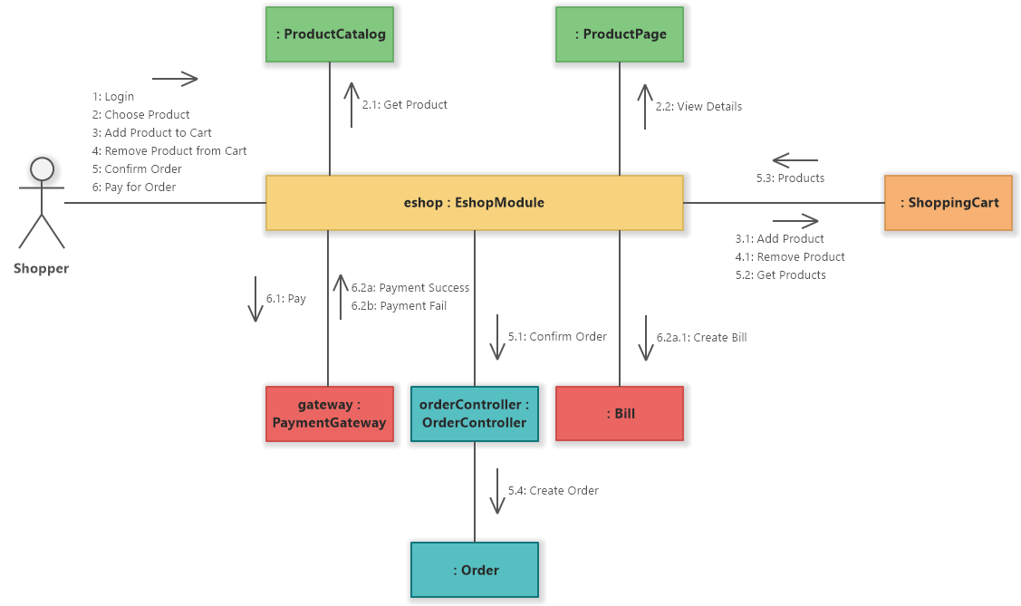

Design Sequence diagram of online food ordering system. 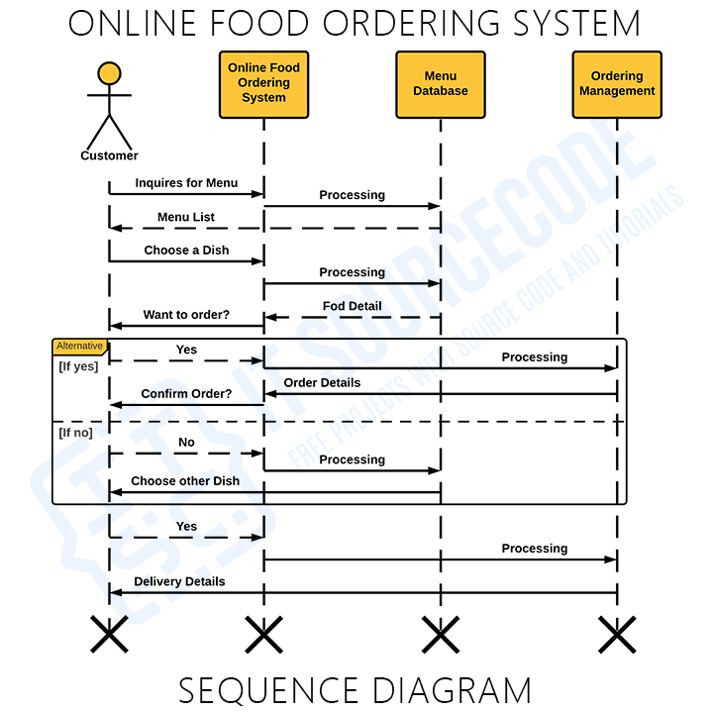

Design State machine for an ATM

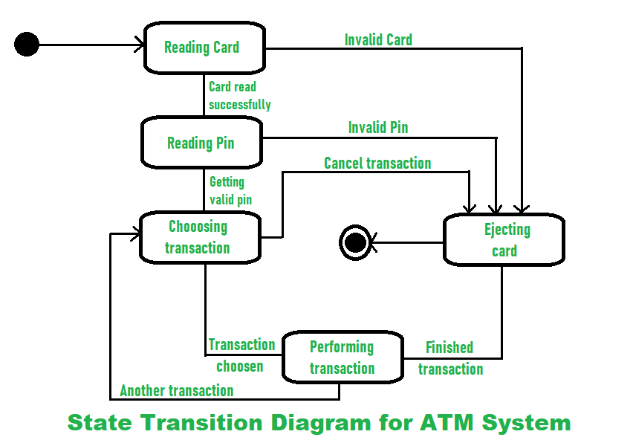

Draw the class diagram for Flight reservation System.

Construct a class diagram for Blood donation system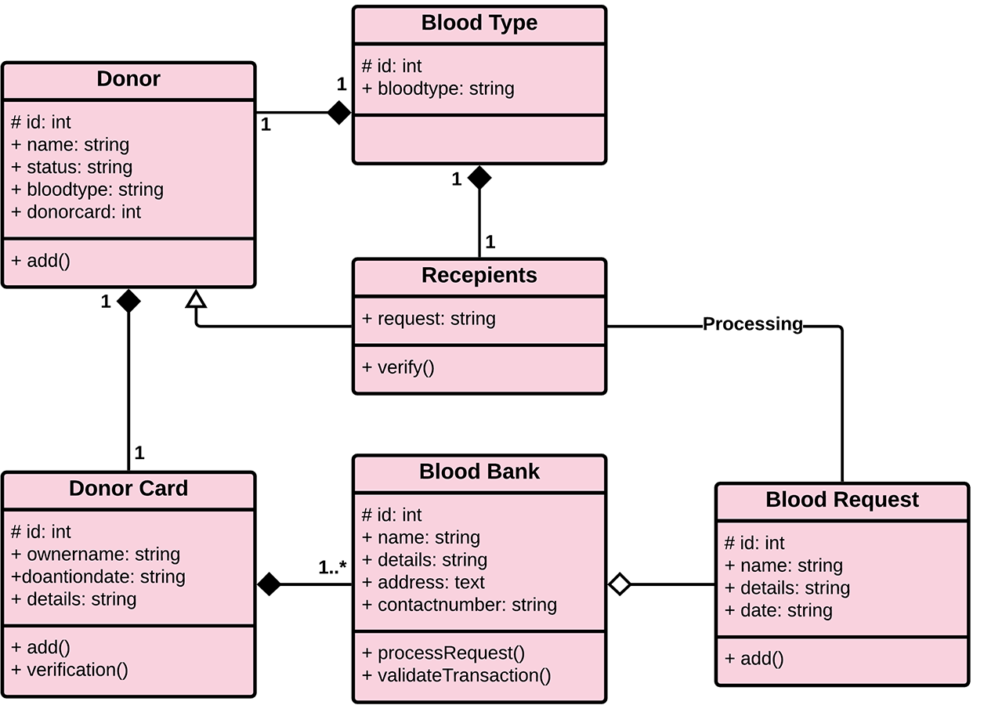

Design Class diagram of Uber application.

Design Class diagram of ATM

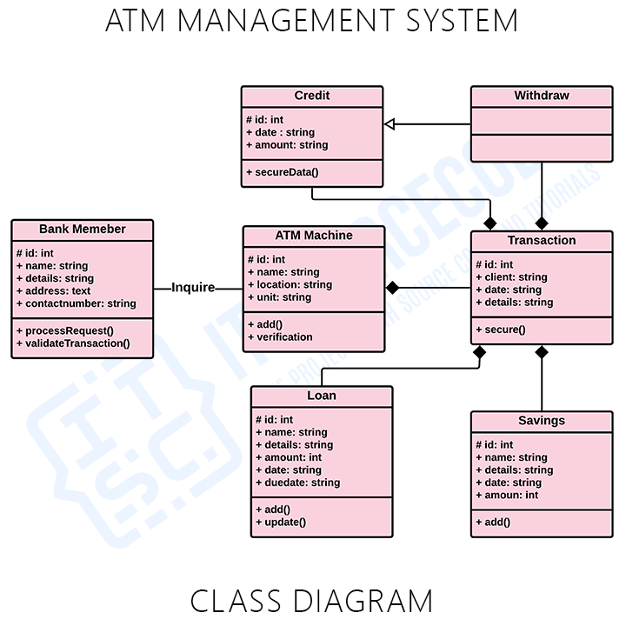

Design Class diagram of Car-Pooling application.

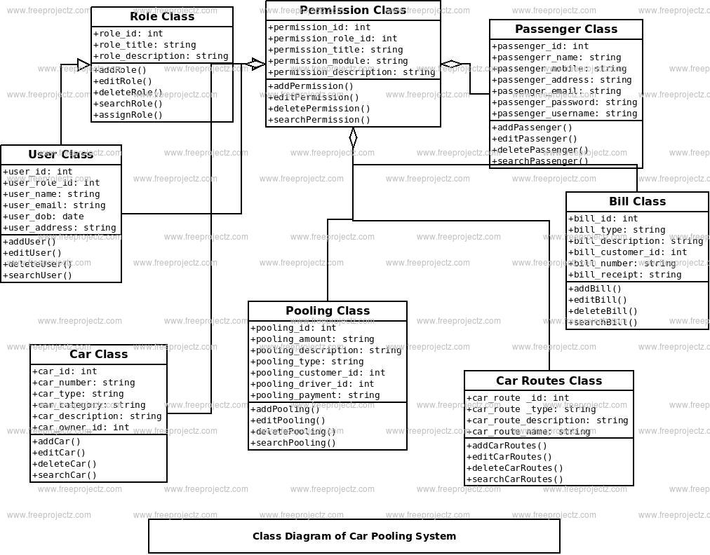

Design A class diagram for Hospital management system

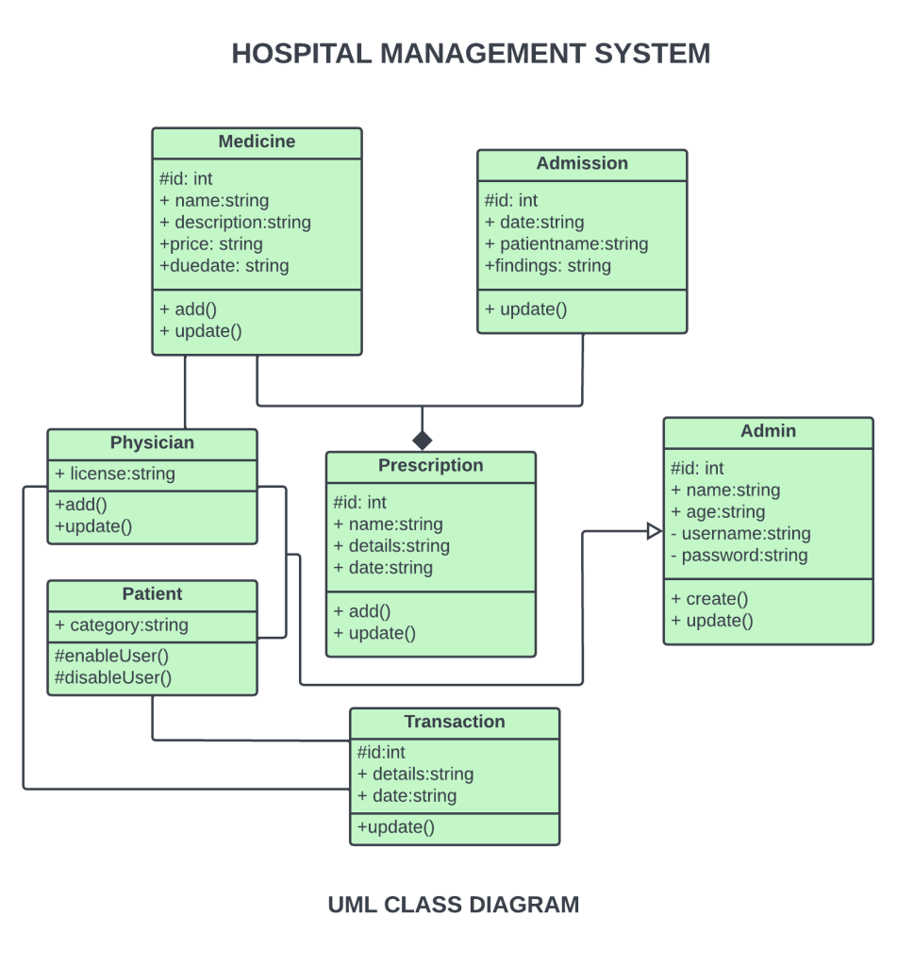

Draw the Class diagram for online exams

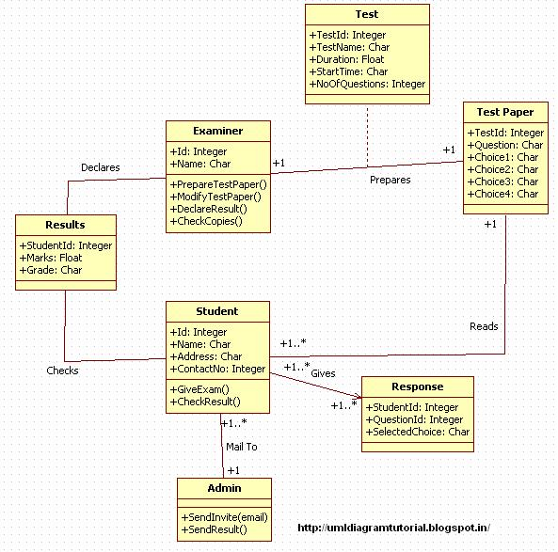

Design Class diagram of Library Management system.

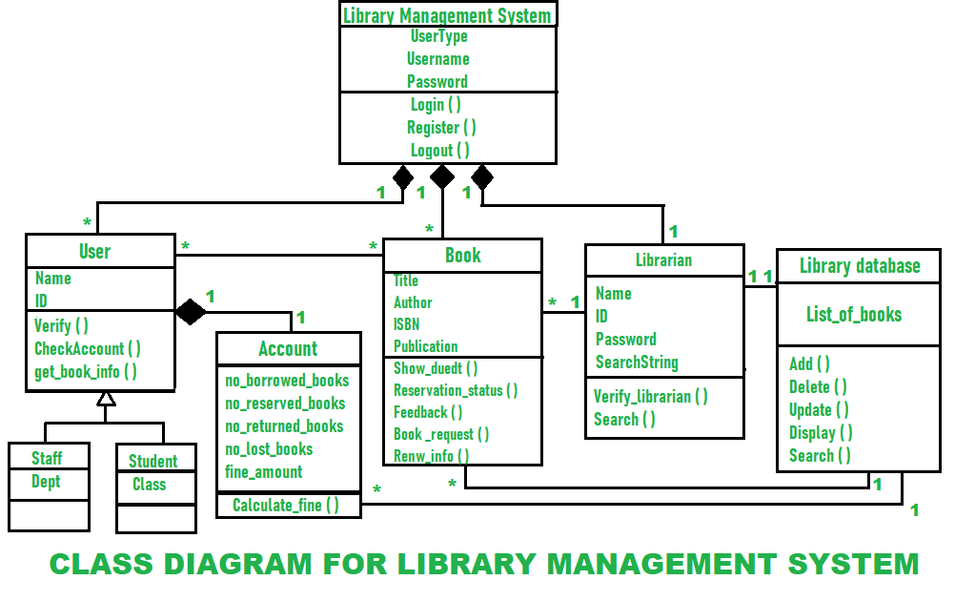

Perform forward and reverse engineering

Write the steps to perform forward engineering and reverse engineering

Design test cases for credit card transactions

Generate test cases for user login process of college web site.

Generate test case report for online movie ticket Booking System

Generate test case report for online shopping Application

Explain about COCOMO model and write equation to Estimate effort and cost

List out some SCM Tools